目 录

1. 实验目的 1

2. 程序流程示意图 2

3. 代码及实现思路分析 3

4. 实验结果 4

5. 感想与收获 5

6. 讨论题 6

7. 源码 10

# 实验目的

了解 UART 串行通讯的工作原理

掌握在 PC 端通过串口调试工具与实验板通过 UART 通讯的方法

掌握 UART 的堵塞式与非堵塞式通讯方法

# 程序流程示意图

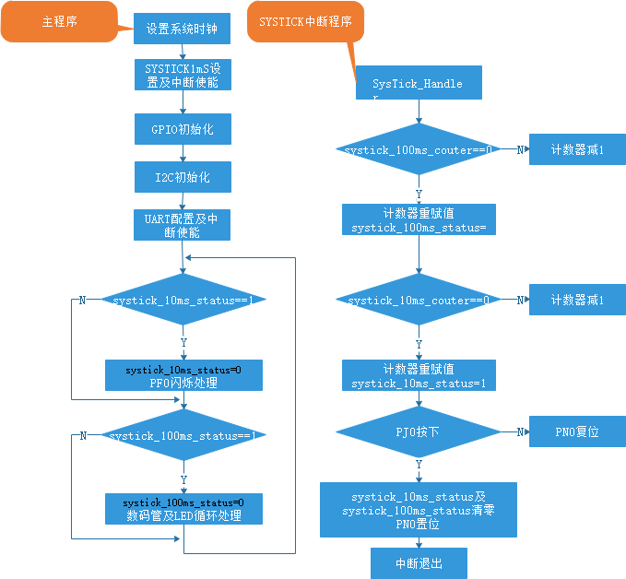

图一、主程序与SYSTICK中断程序逻辑

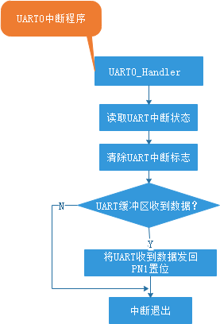

图二、UARTO中断程序逻辑

# 代码及实现思路分析

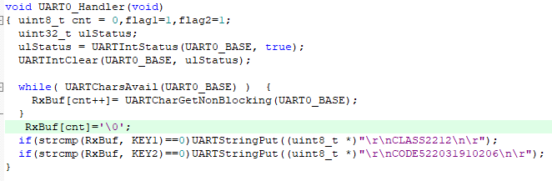

使用UARTCharsAvail(UART0_BASE)检查 UART 接收 FIFO 是否有可用数据，如果有的话就通过UARTCharGetNonBlocking接收并存储到RxBuf数组中。当输入全部被接收后，就使用strcmp函数比较接收到的字符串与“AT+CLASS”和“AT+STUDENTCODE”是否相同，相同便作出对应的输出。

90d6e7ba8ccc5d7cb15919c8563fc0d

使用了非阻塞的方式接收字符串。

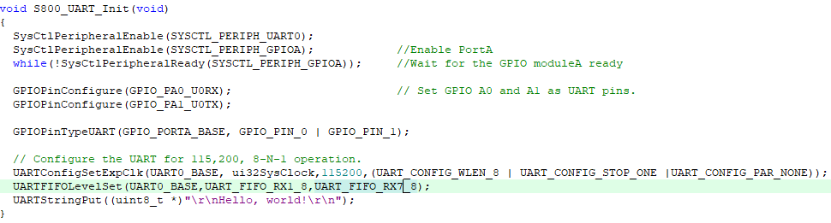

在初始化函数中加入UARTFIFOLevelSet(UART0_BASE,UART_FIFO_RX1_8,UART_FIFO_RX7_8)，便可以成功讲AT+STUDENTCODE发送给串口通信模拟器并被接收。

# 实验结果

按下RESET键后，实验板回以Hello, world!

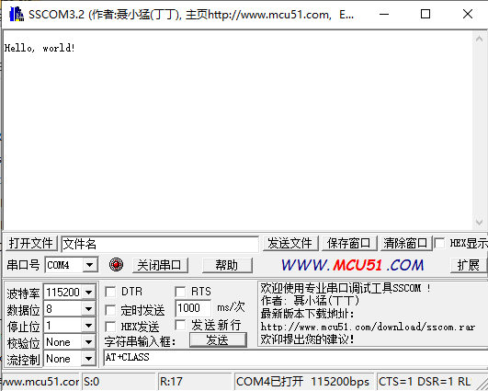

图三、按下RESET

当PC端发来AT+CLASS后，实验板回以CLASS2212

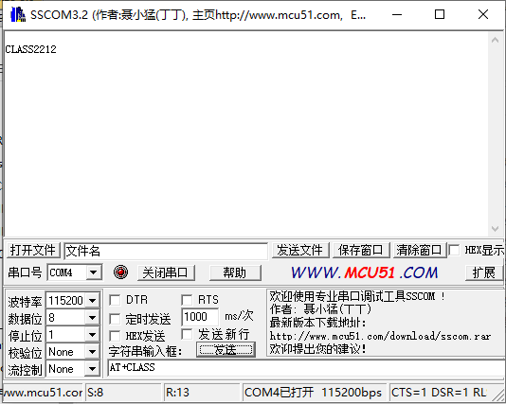

图三、发送AT+CLASS

当PC端发来AT+STUDENTCODE后，实验板回以CODE522031910206

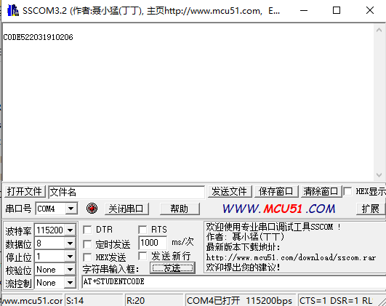

图四、发送AT+STUDENTCODE

# 感想与收获

学会了串口通信模拟器的使用方式：

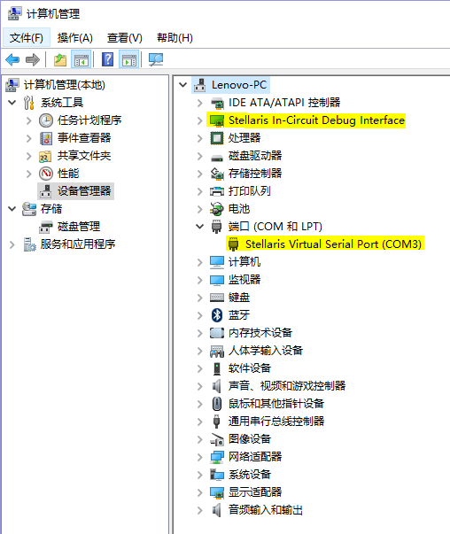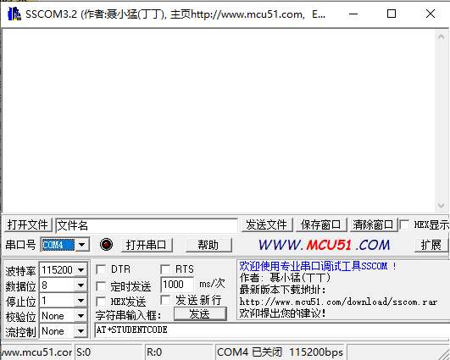

图五、配置虚拟串口通信模拟器

在虚拟机中讲串口号改为COM4,将波特率改为115200便可开始模拟通信。左下方的S代表发出的字节数，左下方的R代表读取到的字节数。

学会了使用库函数与UARTFIFOLevelSet函数来简化代码逻辑，实现性能更强的通信：

将传输的信息通过SSCOM的信息输入框发送给主板。在初始化函数中加入UARTFIFOLevelSet(UART0_BASE,UART_FIFO_RX1_8,UART_FIFO_RX7_8)函数保证可以发送较长的文本。通过非阻塞的方式接收字符串后，利用C语言库中的strcmp函数来进行字符串的比较。并做出对应的返回。

# 讨论题

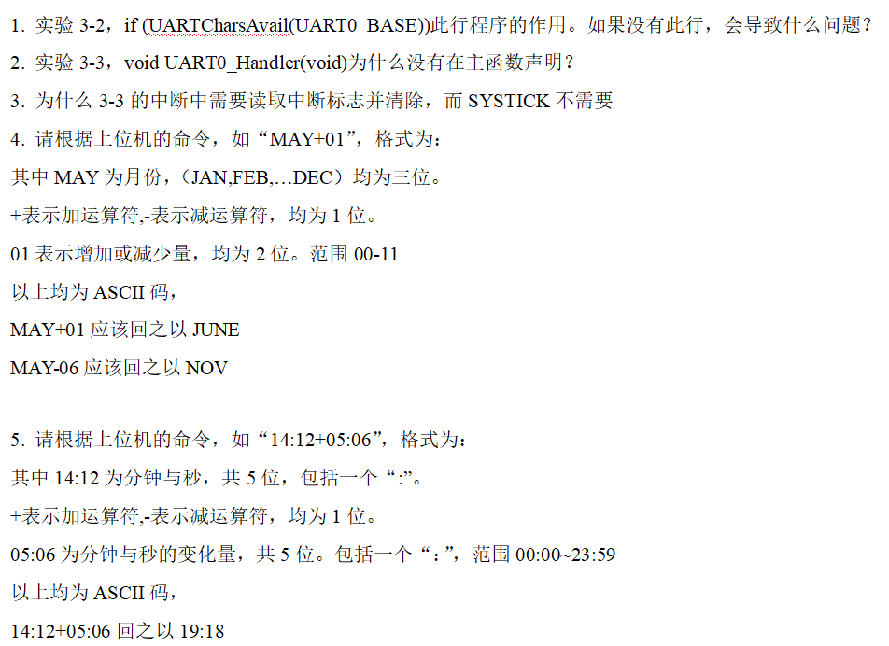

1. 作用：

UARTCharsAvail(UART0_BASE)用于检查 UART 接收 FIFO 是否有可用数据。如果没有这行代码，会导致以下问题：

(1).数据读取错误：直接读取可能会发生在没有数据可读的情况下，读取到无效或错误数据。

(2).程序崩溃或陷入死循环：如果读取操作依赖于此检查，缺少它会导致程序读取错误地址或数据，可能崩溃或进入死循环。

2. 没有在主函数声明的原因：

中断处理函数 UART0_Handler不需要在主函数中声明，因为它是在启动文件或系统中断向量表中声明和定义的。这是一个惯例，中断处理函数由硬件中断向量表直接调用。

3. 3-3的中断中需要读取中断标志并清除，而SYSTICK不需要的原因:

(1).UART中断：UART 中断标志在触发后需要被清除，以防止中断处理程序反复处理相同的中断事件。通常是通过读取相关寄存器并进行清除操作。

(2).SysTick中断：SysTick 计时器在每次溢出时自动触发中断，不需要手动清除中断标志。SysTick 定时器自动重装和溢出处理机制不需要用户代码清除标志。

4.

#include <stdio.h>

#include <string.h>

const char *months[] = {

"JAN", "FEB", "MAR", "APR", "MAY", "JUN", "JUL", "AUG", "SEP", "OCT", "NOV", "DEC"

};

int getMonthIndex(const char *month) {

for (int i = 0; i < 12; i++) {

if (strncmp(months[i], month, 3) == 0) {

return i;

}

}

return -1; // 错误月份

}

void processMonthCommand(const char *command) {

char month[4] = {0};

strncpy(month, command, 3);

char op = command[3];

int value = (command[4] - '0') * 10 + (command[5] - '0');

int monthIndex = getMonthIndex(month);

if (monthIndex == -1) {

printf("Invalid month\n");

return;

}

if (op == '+') {

monthIndex = (monthIndex + value) % 12;

} else if (op == '-') {

monthIndex = (monthIndex - value + 12) % 12;

} else {

printf("Invalid operation\n");

return;

}

printf("Result: %s\n", months[monthIndex]);

}

int main() {

processMonthCommand("MAY+01"); // Expected output: JUNE

processMonthCommand("MAY-06"); // Expected output: NOV

return 0;

}

5.

#include <stdio.h>

#include <stdlib.h>

#include <string.h>

// 解析时间字符串 "MM:SS"

void parseTime(const char *timeStr, int *minutes, int *seconds) {

*minutes = (timeStr[0] - '0') * 10 + (timeStr[1] - '0');

*seconds = (timeStr[3] - '0') * 10 + (timeStr[4] - '0');

}

// 将分钟和秒数转换回字符串 "MM:SS"

void formatTime(int minutes, int seconds, char *timeStr) {

snprintf(timeStr, 6, "%02d:%02d", minutes, seconds);

}

void processTimeCommand(const char *command) {

int minutes1, seconds1;

int minutes2, seconds2;

char result[6];

parseTime(command, &minutes1, &seconds1);

parseTime(command + 6, &minutes2, &seconds2);

char op = command[5];

int totalSeconds1 = minutes1 * 60 + seconds1;

int totalSeconds2 = minutes2 * 60 + seconds2;

int resultSeconds;

if (op == '+') {

resultSeconds = totalSeconds1 + totalSeconds2;

} else if (op == '-') {

resultSeconds = totalSeconds1 - totalSeconds2;

} else {

printf("Invalid operation\n");

return;

}

if (resultSeconds < 0) {

resultSeconds += 24 * 60 * 60; // 处理负时间

}

int resultMinutes = (resultSeconds / 60) % (24 * 60);

resultSeconds = resultSeconds % 60;

formatTime(resultMinutes, resultSeconds, result);

printf("Result: %s\n", result);

}

int main() {

processTimeCommand("14:12+05:06"); // Expected output: 19:18

return 0;

}

# 源码

#include <stdint.h>

#include <stdbool.h>

#include <string.h>

#include "hw_memmap.h"

#include "debug.h"

#include "gpio.h"

#include "hw_i2c.h"

#include "hw_types.h"

#include "i2c.h"

#include "pin_map.h"

#include "sysctl.h"

#include "systick.h"

#include "interrupt.h"

#include "uart.h"

#include "hw_ints.h"

#define SYSTICK_FREQUENCY 1000 //1000hz

#define I2C_FLASHTIME 500 //500mS

#define GPIO_FLASHTIME 300 //300mS

//*****************************************************************************

//

//I2C GPIO chip address and resigster define

//

//*****************************************************************************

#define TCA6424_I2CADDR 0x22

#define PCA9557_I2CADDR 0x18

#define PCA9557_INPUT 0x00

#define PCA9557_OUTPUT 0x01

#define PCA9557_POLINVERT 0x02

#define PCA9557_CONFIG 0x03

#define TCA6424_CONFIG_PORT0 0x0c

#define TCA6424_CONFIG_PORT1 0x0d

#define TCA6424_CONFIG_PORT2 0x0e

#define TCA6424_INPUT_PORT0 0x00

#define TCA6424_INPUT_PORT1 0x01

#define TCA6424_INPUT_PORT2 0x02

#define TCA6424_OUTPUT_PORT0 0x04

#define TCA6424_OUTPUT_PORT1 0x05

#define TCA6424_OUTPUT_PORT2 0x06

void Delay(uint32_t value);

void S800_GPIO_Init(void);

uint8_t I2C0_WriteByte(uint8_t DevAddr, uint8_t RegAddr, uint8_t WriteData);

uint8_t I2C0_ReadByte(uint8_t DevAddr, uint8_t RegAddr);

void S800_I2C0_Init(void);

void S800_UART_Init(void);

//systick software counter define

volatile uint16_t systick_10ms_couter,systick_100ms_couter;

volatile uint8_t systick_10ms_status,systick_100ms_status;

volatile uint8_t result,cnt,key_value,gpio_status;

volatile uint8_t rightshift = 0x01;

uint32_t ui32SysClock;

uint8_t seg7[] = {0x3f,0x06,0x5b,0x4f,0x66,0x6d,0x7d,0x07,0x7f,0x6f,0x77,0x7c,0x58,0x5e,0x079,0x71,0x5c};

uint8_t uart_receive_char;

char *uart_receive_string;

char *KEY1="AT+CLASS";

char *KEY2="AT+STUDENTCODE";

char RxBuf[100];

int main(void)

{

volatile uint16_t i2c_flash_cnt,gpio_flash_cnt;

//use internal 16M oscillator, PIOSC

//ui32SysClock = SysCtlClockFreqSet((SYSCTL_XTAL_16MHZ |SYSCTL_OSC_INT |SYSCTL_USE_OSC), 16000000);

//ui32SysClock = SysCtlClockFreqSet((SYSCTL_XTAL_16MHZ |SYSCTL_OSC_INT |SYSCTL_USE_OSC), 8000000);

//use external 25M oscillator, MOSC

//ui32SysClock = SysCtlClockFreqSet((SYSCTL_XTAL_25MHZ |SYSCTL_OSC_MAIN |SYSCTL_USE_OSC), 25000000);

//use external 25M oscillator and PLL to 120M

//ui32SysClock = SysCtlClockFreqSet((SYSCTL_XTAL_25MHZ |SYSCTL_OSC_MAIN | SYSCTL_USE_PLL |SYSCTL_CFG_VCO_480), 120000000);;

ui32SysClock = SysCtlClockFreqSet((SYSCTL_OSC_INT | SYSCTL_USE_PLL |SYSCTL_CFG_VCO_480), 20000000);

SysTickPeriodSet(ui32SysClock/SYSTICK_FREQUENCY);

SysTickEnable();

SysTickIntEnable(); //Enable Systick interrupt

S800_GPIO_Init();

S800_I2C0_Init();

S800_UART_Init();

IntEnable(INT_UART0);

UARTIntEnable(UART0_BASE, UART_INT_RX | UART_INT_RT); //Enable UART0 RX,TX interrupt

IntMasterEnable();

while (1)

{

if (systick_10ms_status)

{

systick_10ms_status = 0;

if (++gpio_flash_cnt >= GPIO_FLASHTIME/10)

{

gpio_flash_cnt = 0;

if (gpio_status)

GPIOPinWrite(GPIO_PORTF_BASE, GPIO_PIN_0,GPIO_PIN_0 );

else

GPIOPinWrite(GPIO_PORTF_BASE, GPIO_PIN_0,0);

gpio_status = !gpio_status;

}

}

if (systick_100ms_status)

{

systick_100ms_status = 0;

if (++i2c_flash_cnt >= I2C_FLASHTIME/100)

{

i2c_flash_cnt = 0;

result = I2C0_WriteByte(TCA6424_I2CADDR,TCA6424_OUTPUT_PORT1,seg7[cnt+1]); //write port 1

result = I2C0_WriteByte(TCA6424_I2CADDR,TCA6424_OUTPUT_PORT2,rightshift); //write port 2

result = I2C0_WriteByte(PCA9557_I2CADDR,PCA9557_OUTPUT,~rightshift);

cnt++;

rightshift= rightshift<<1;

if (cnt >= 0x8)

{

rightshift= 0x01;

cnt = 0;

}

}

}

}

}

void Delay(uint32_t value)

{

uint32_t ui32Loop;

for(ui32Loop = 0; ui32Loop < value; ui32Loop++){};

}

void UARTStringPut(uint8_t *cMessage)

{

while(*cMessage!='\0')

UARTCharPut(UART0_BASE,*(cMessage++));

}

void UARTStringPutNonBlocking(const char *cMessage)

{

while(*cMessage!='\0')

UARTCharPutNonBlocking(UART0_BASE,*(cMessage++));

}

void S800_UART_Init(void)

{

SysCtlPeripheralEnable(SYSCTL_PERIPH_UART0);

SysCtlPeripheralEnable(SYSCTL_PERIPH_GPIOA); //Enable PortA

while(!SysCtlPeripheralReady(SYSCTL_PERIPH_GPIOA)); //Wait for the GPIO moduleA ready

GPIOPinConfigure(GPIO_PA0_U0RX); // Set GPIO A0 and A1 as UART pins.

GPIOPinConfigure(GPIO_PA1_U0TX);

GPIOPinTypeUART(GPIO_PORTA_BASE, GPIO_PIN_0 | GPIO_PIN_1);

// Configure the UART for 115,200, 8-N-1 operation.

UARTConfigSetExpClk(UART0_BASE, ui32SysClock,115200,(UART_CONFIG_WLEN_8 | UART_CONFIG_STOP_ONE |UART_CONFIG_PAR_NONE));

UARTFIFOLevelSet(UART0_BASE,UART_FIFO_RX1_8,UART_FIFO_RX7_8);

UARTStringPut((uint8_t *)"\r\nHello, world!\r\n");

}

void S800_GPIO_Init(void)

{

SysCtlPeripheralEnable(SYSCTL_PERIPH_GPIOF); //Enable PortF

while(!SysCtlPeripheralReady(SYSCTL_PERIPH_GPIOF)); //Wait for the GPIO moduleF ready

SysCtlPeripheralEnable(SYSCTL_PERIPH_GPIOJ); //Enable PortJ

while(!SysCtlPeripheralReady(SYSCTL_PERIPH_GPIOJ)); //Wait for the GPIO moduleJ ready

SysCtlPeripheralEnable(SYSCTL_PERIPH_GPION); //Enable PortN

while(!SysCtlPeripheralReady(SYSCTL_PERIPH_GPION)); //Wait for the GPIO moduleN ready

GPIOPinTypeGPIOOutput(GPIO_PORTF_BASE, GPIO_PIN_0); //Set PF0 as Output pin

GPIOPinTypeGPIOOutput(GPIO_PORTN_BASE, GPIO_PIN_0); //Set PN0 as Output pin

GPIOPinTypeGPIOOutput(GPIO_PORTN_BASE, GPIO_PIN_1); //Set PN1 as Output pin

GPIOPinTypeGPIOInput(GPIO_PORTJ_BASE,GPIO_PIN_0 | GPIO_PIN_1);//Set the PJ0,PJ1 as input pin

GPIOPadConfigSet(GPIO_PORTJ_BASE,GPIO_PIN_0 | GPIO_PIN_1,GPIO_STRENGTH_2MA,GPIO_PIN_TYPE_STD_WPU);

}

void S800_I2C0_Init(void)

{

uint8_t result;

SysCtlPeripheralEnable(SYSCTL_PERIPH_I2C0);

SysCtlPeripheralEnable(SYSCTL_PERIPH_GPIOB);

GPIOPinConfigure(GPIO_PB2_I2C0SCL);

GPIOPinConfigure(GPIO_PB3_I2C0SDA);

GPIOPinTypeI2CSCL(GPIO_PORTB_BASE, GPIO_PIN_2);

GPIOPinTypeI2C(GPIO_PORTB_BASE, GPIO_PIN_3);

I2CMasterInitExpClk(I2C0_BASE,ui32SysClock, true); //config I2C0 400k

I2CMasterEnable(I2C0_BASE);

result = I2C0_WriteByte(TCA6424_I2CADDR,TCA6424_CONFIG_PORT0,0x0ff); //config port 0 as input

result = I2C0_WriteByte(TCA6424_I2CADDR,TCA6424_CONFIG_PORT1,0x0); //config port 1 as output

result = I2C0_WriteByte(TCA6424_I2CADDR,TCA6424_CONFIG_PORT2,0x0); //config port 2 as output

result = I2C0_WriteByte(PCA9557_I2CADDR,PCA9557_CONFIG,0x00); //config port as output

result = I2C0_WriteByte(PCA9557_I2CADDR,PCA9557_OUTPUT,0x0ff); //turn off the LED1-8

}

uint8_t I2C0_WriteByte(uint8_t DevAddr, uint8_t RegAddr, uint8_t WriteData)

{

uint8_t rop;

while(I2CMasterBusy(I2C0_BASE)){};

I2CMasterSlaveAddrSet(I2C0_BASE, DevAddr, false);

I2CMasterDataPut(I2C0_BASE, RegAddr);

I2CMasterControl(I2C0_BASE, I2C_MASTER_CMD_BURST_SEND_START);

while(I2CMasterBusy(I2C0_BASE)){};

rop = (uint8_t)I2CMasterErr(I2C0_BASE);

I2CMasterDataPut(I2C0_BASE, WriteData);

I2CMasterControl(I2C0_BASE, I2C_MASTER_CMD_BURST_SEND_FINISH);

while(I2CMasterBusy(I2C0_BASE)){};

rop = (uint8_t)I2CMasterErr(I2C0_BASE);

return rop;

}

uint8_t I2C0_ReadByte(uint8_t DevAddr, uint8_t RegAddr)

{

uint8_t value,rop;

while(I2CMasterBusy(I2C0_BASE)){};

I2CMasterSlaveAddrSet(I2C0_BASE, DevAddr, false);

I2CMasterDataPut(I2C0_BASE, RegAddr);

// I2CMasterControl(I2C0_BASE, I2C_MASTER_CMD_BURST_SEND_START);

I2CMasterControl(I2C0_BASE,I2C_MASTER_CMD_SINGLE_SEND);

while(I2CMasterBusBusy(I2C0_BASE));

rop = (uint8_t)I2CMasterErr(I2C0_BASE);

Delay(1);

//receive data

I2CMasterSlaveAddrSet(I2C0_BASE, DevAddr, true);

I2CMasterControl(I2C0_BASE,I2C_MASTER_CMD_SINGLE_RECEIVE);

while(I2CMasterBusBusy(I2C0_BASE));

value=I2CMasterDataGet(I2C0_BASE);

Delay(1);

return value;

}

/*

Corresponding to the startup_TM4C129.s vector table systick interrupt program name

*/

void SysTick_Handler(void)

{

if (systick_100ms_couter != 0)

systick_100ms_couter--;

else

{

systick_100ms_couter = SYSTICK_FREQUENCY/10;

systick_100ms_status = 1;

}

if (systick_10ms_couter != 0)

systick_10ms_couter--;

else

{

systick_10ms_couter = SYSTICK_FREQUENCY/100;

systick_10ms_status = 1;

}

if (GPIOPinRead(GPIO_PORTJ_BASE,GPIO_PIN_0) == 0)

{

systick_100ms_status = systick_10ms_status = 0;

GPIOPinWrite(GPIO_PORTN_BASE, GPIO_PIN_0,GPIO_PIN_0);

}

else

GPIOPinWrite(GPIO_PORTN_BASE, GPIO_PIN_0,0);

}

/*

Corresponding to the startup_TM4C129.s vector table UART0_Handler interrupt program name

*/

/*

void UART0_Handler(void)

{

int32_t uart0_int_status;

uart0_int_status = UARTIntStatus(UART0_BASE, true); // Get the interrrupt status.

UARTIntClear(UART0_BASE, uart0_int_status); //Clear the asserted interrupts

while(UARTCharsAvail(UART0_BASE)) // Loop while there are characters in the receive FIFO.

{

///Read the next character from the UART and write it back to the UART.

//UARTCharPutNonBlocking(UART0_BASE,UARTCharGetNonBlocking(UART0_BASE));

//GPIOPinWrite(GPIO_PORTN_BASE, GPIO_PIN_1,GPIO_PIN_1 );

// Delay(1000);

}

//GPIOPinWrite(GPIO_PORTN_BASE, GPIO_PIN_1,0 );

}

*/

void UARTStringGet(uint32_t ui32Base,char *cMessage,const char Iden)

{

while(1)

{

*cMessage=UARTCharGet(ui32Base);

if(*cMessage!=Iden)

{

cMessage=cMessage+1;

}

else

{

*cMessage='\0';

break;

}

}

}

void UART0_Handler(void)

{ uint8_t cnt = 0,flag1=1,flag2=1;

uint32_t ulStatus;

ulStatus = UARTIntStatus(UART0_BASE, true);

UARTIntClear(UART0_BASE, ulStatus);

while( UARTCharsAvail(UART0_BASE) ) {

RxBuf[cnt++]= UARTCharGetNonBlocking(UART0_BASE);

}

RxBuf[cnt]='\0';

if(strcmp(RxBuf, KEY1)==0)UARTStringPut((uint8_t *)"\r\nCLASS2212\n\r");

if(strcmp(RxBuf, KEY2)==0)UARTStringPut((uint8_t *)"\r\nCODE522031910206\n\r");

}